Using the Infant Mortality Research Partnership (IMRP) Medicaid Perinatal Risk Tool (MPRT)
Perinatal Risk Assessment Form – Electronic Health Record (PRAF-EHR)
User Guide for Epic Hyperspace® Users





Version 13.1, August 27, 2026

User Guide for Epic Hyperspace® Users

Welcome
This document is intended to help you get started with using the Perinatal Risk Assessment Form-Electronic Health Record (PRAF-EHR) in Epic.

What is the Medicaid Perinatal Risk Tool?
The Infant Mortality Research Partnership (IMRP) has developed a suite of infant mortality and maternal health tools built on the Microsoft Azure cloud computing platform. The full suite of tools is called the Medicaid Perinatal Risk Tool (MPRT). The MPRT is designed for Epic-using health providers and intended for use in an ambulatory patient encounter. The MPRT currently consists of three tools:
- PRAF-EHR: Perinatal Risk Assessment Form tool that utilizes data from patient’s EHR
- IM/PTB RC: Infant mortality and preterm birth risk calculator
- SMM-RC: Severe Maternal Morbidity risk calculator (Forthcoming)
The Medicaid Perinatal Risk Tool PRAF-EHR automatically extracts PRAF data from the medical record (EHR), using the patient’s MRN and the provider’s Epic ID. The user can quickly review the data, then send that data to the NurtureOhio PRAF 2.0 Ohio Department of Medicaid’s Online Notification of Pregnancy System website via a single click. The PRAF is then reviewed in the NurtureOhio PRAF system, edited if needed, and submitted for validation.

What do I need from Epic Hyperspace®?
Here are the prerequisites that you will need from Epic Hyperspace® before using the PRAF-EHR.
- Access to an Epic Hyperspace® account/login credentials
- Experience finding patients and navigating to encounters in Epic Hyperspace®

What do I need from NurtureOhio?
Here are the prerequisites that you will need from NurtureOhio before using the PRAF-EHR.
- Access to NurtureOhio account/login credentials
  - To submit PRAFs, you must be a registered user of NurtureOhio with an OH|ID and have the "prenatal visit" role assigned for each MCID you are affiliated with.
  - For information on how to gain access to NurtureOhio, see the: PRAF 2.0 NurtureOhio Interface: Medicaid Provider User Guide
  - If you do not currently have access or are having issues with access to NurtureOhio, please email Momsandbabies@medicaid.ohio.gov
- Access to NurtureOhio token for the practice for which the PRAF is being sent
  - Token is found in your NurtureOhio User account (See below "How do I get a NurtureOhio PRAF-EHR Token?")
  - Verify practice credentials
  - Verify users

How do I get a NurtureOhio PRAF-EHR token?

NurtureOhio website and copying the NurtureOhio PRAF token
Before launching PRAF-EHR, login to the NurtureOhio PRAF website at https://nurtureohio.medicaid.ohio.gov so you can obtain a token and also monitor the transmission of your submitted PRAFs.
If you do not yet have a NurtureOhio account, instructions for setting up an account can be found in the NurtureOhio Provider Medicaid User Guide.
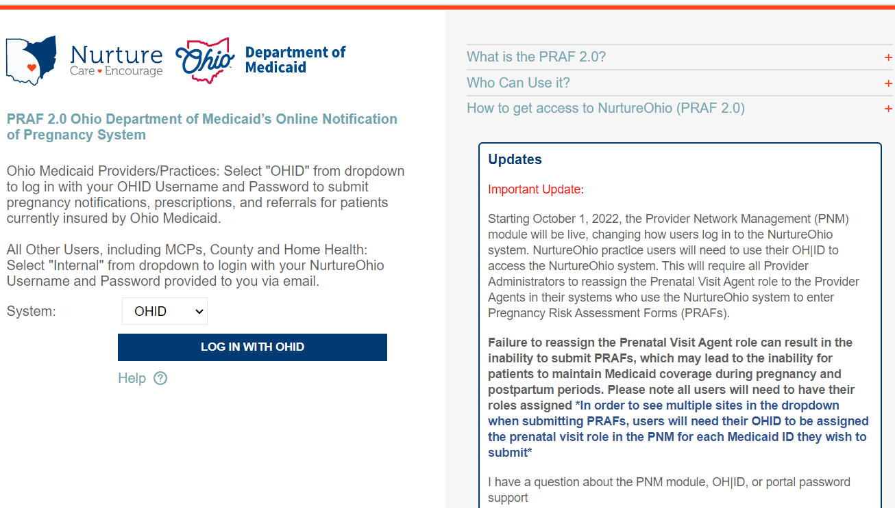

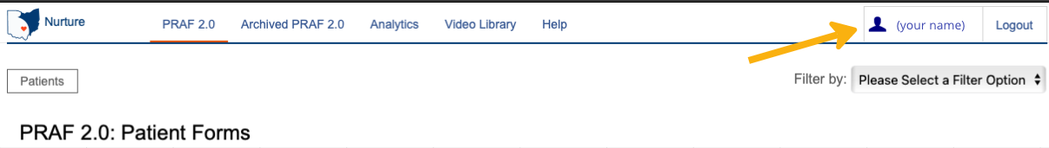
After logging in, open your account by selecting your name link in the upper right corner.

The "Edit User Profile" page will open. Under the EHR Token(s) heading, each practice for which you have the credentials to file based on the prenatal visit role assignment in the Provider Network Management (PNM) system will be listed along with a link to the unique token for each practice (Note: the actual token code is not visible on the screen). Each practice link shows the name and location of the practice along with "Copy to Clipboard."
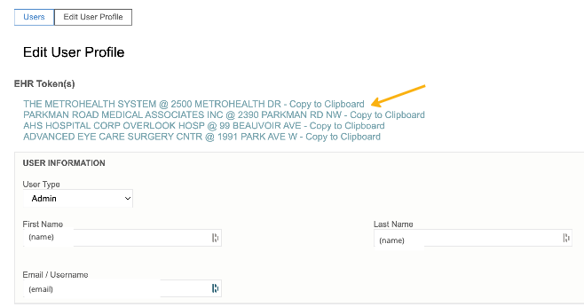

About the NurtureOhio PRAF Token
A NurtureOhio token for the practice for which you want to file a PRAF will be needed when using the PRAF-EHR tool. The token is an encrypted identifier for both the user and the practice for which the user is associated. A user may have multiple tokens, one for each practice site the user is associated with.
Once a token is assigned, it does not change -- you'll use that same token every time you file a PRAF for the associated practice. The token also automatically adds the user, practice, and some provider identifiers to the PRAF form so those do not have to be manually entered. In addition, the user and practice identifiers make it possible to track the PRAF so it is retrievable after it is submitted.

To get the token, click on the practice name and "Copy to Clipboard" link. This copies the token to your clipboard so it can later be pasted into the PRAF-EHR form.
The token will look something like this: gBb6Dy:hW7tEa
Workflow Tips: Since the token needed for a PRAF submission for a practice does not change, you may want to paste your practice site token(s) into a Word doc (or .txt file) and then save that file for easy access. This allows the practice site token(s) to be available without having to open the NurtureOhio website repeatedly to copy a token.
For users with multiple practice sites, organizing work by practice site is suggested so that the copied practice site token can be repeatedly pasted into all the PRAFs for that practice site before moving onto the next practice site.

After you have copied or written down the token, you are ready to use the PRAF-EHR.

What is a summary of the workflow steps for using the PRAF-EHR?
- From NurtureOhio website, copy the EHR token for the appropriate practice
- Log in to Epic Hyperspace, pull up the patient and appropriate encounter
- Launch the Medicaid Perinatal Risk Assessment tool
- Fill out any form fields if needed (manual entry fields)
- Paste or type in the NurtureOhio token & send the PRAF data to NurtureOhio
- Receive confirmation that the PRAF was successfully sent to NurtureOhio
If a PRAF fails, contact support at imrp@osumc.edu
- At the NurtureOhio website, log in to view the sent PRAF
- Review the PRAF in NurtureOhio website and edit, make changes if needed
- In the NurtureOhio website, finalize the form and submit to Ohio Department of Medicaid.

Using the PRAF-EHR tool
The Medicaid Perinatal Risk Tool with PRAF-EHR is launches from within Epic Hyperspace, so you will first need to log in to Epic Hyperspace. Note: The specific location and name of the Medicaid Perinatal Risk Tool within Epic Hyperspace, and the encounter types for which the app will be available, will be determined by your practice/hospital group's Epic implementation team and clinical operations subject matter experts (OB, MFM, ambulatory, etc.).
- Log in to your organization's Epic Hyperspace, which may look similar to this:
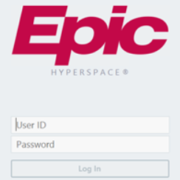
- Locate the patient for which you will initiate a PRAF (Note that there are many ways to pull-up a patient record via Epic Hyperspace. The example here demonstrates one common path.)

- Select "Patient Station" and then "Recent Patients" or select Patient Lookup and enter MRN to bring up the patient record.
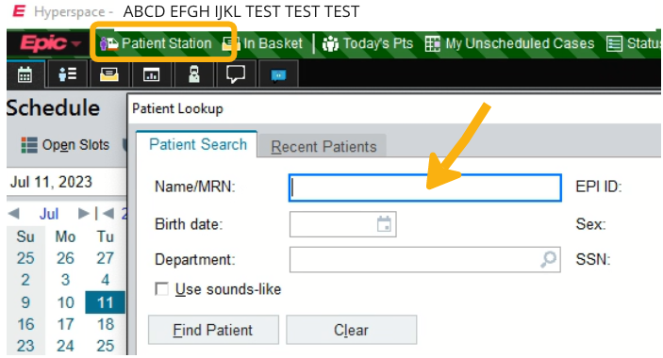

- Select the appropriate existing Encounter (Note: your workflow may vary; check with your Epic team and clinician operations team to obtain a list of which Encounter types your practice has selected for use with the Medicaid Perinatal Risk Tool app and which Encounter type should be used to initiate a PRAF).
  - When the Encounter is open, select the "More" menu arrow. This will expand to display all apps available for this Encounter type in Hyperspace:
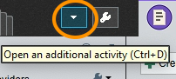
- Locate the Medicaid Perinatal Risk Tool. Note that the list of available apps varies by organization. The image below is provided as an example only.
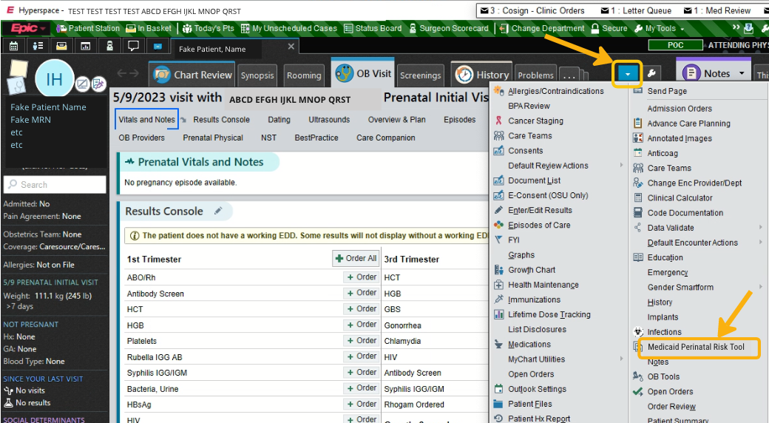
Workflow Tip: To add the MPRT to your Hyperspace favorites, select the star icon to the right of the listing. This will make the MPRT tool appear in the main tab menu going forward.

- Click on the Medicaid Perinatal Risk Tool option from the menu or from the tab to launch the tool. The Medicaid Perinatal Risk Tool will open in a new window.
- For a prenatal PRAF, click on the Prenatal tab and enter the Gestational Age (in weeks), select the PRAF-EHR radio button, and select Submit. If submitting a postpartum PRAF, click on the Postpartum tab and enter the gestational weeks at the time of birth.
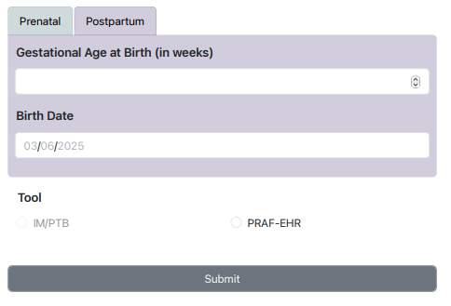
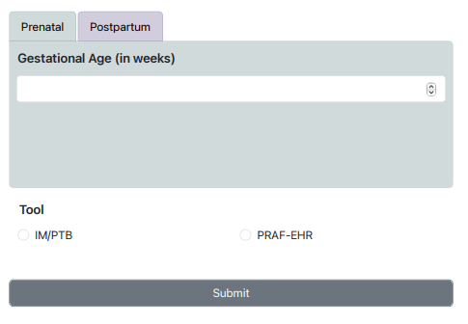

- The PRAF-EHR form opens and is populated with mandatory PRAF data pulled from the patient's EHR. See Appendix A for a complete list of data being pulled in from the EHR.
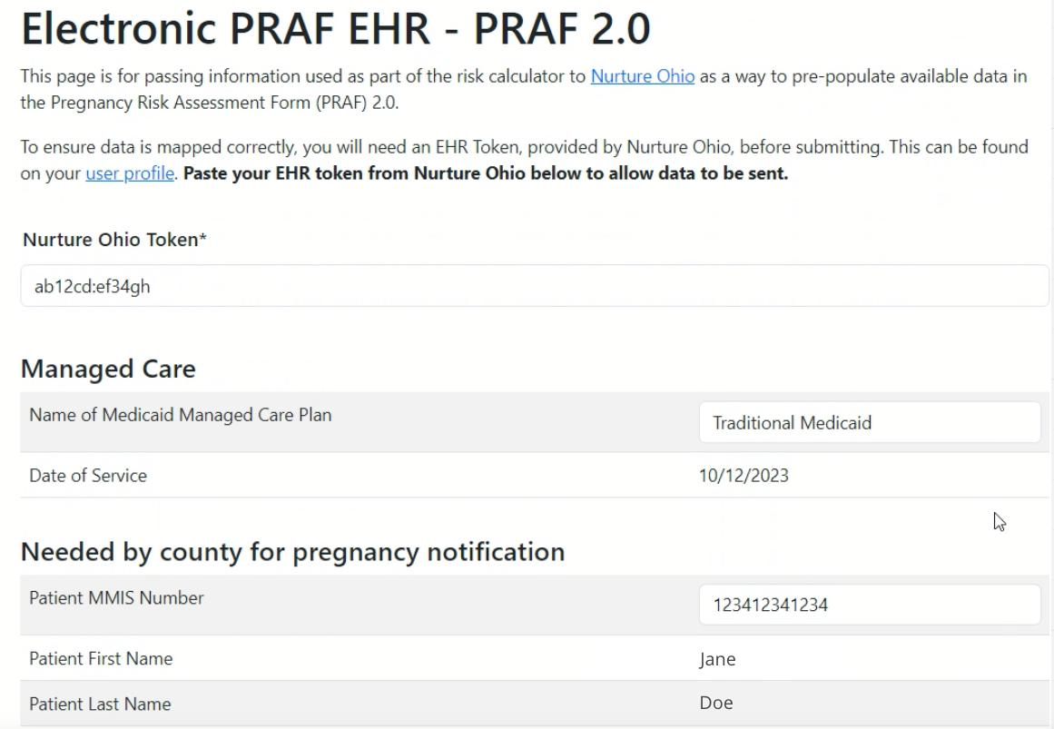
- In addition to the PRAF data automatically pulled in from the EHR, there are manual entry fields provided to enter additional PRAF information:
  - Managed Care: "Name of Medicaid Managed Care Organization"
- If the "Name of Medicaid Managed Care Organization " does not automatically appear, select a plan from the dropdown list provided. Options include: AmeriHealth, Anthem, Buckeye, CareSource, Humana, Molina, United Healthcare Community Plan, Traditional Medicaid.
- Note: This field is mandatory. A PRAF-EHR will be rejected in the validation step of NurtureOhio if this is not completed.
  - If the Patient MMIS (Medicaid ID) Number is blank, you will need to manually enter the number (12 digits). For patients that do not have an MMIS Number, you should submit a PRAF manually on the NurtureOhio website using the patient’s social security number.

  - Patient Phone and Patient Alternate Phone. If the field “Cell Phone” is checked, the following field will appear “Permission for MCO to text patient.”

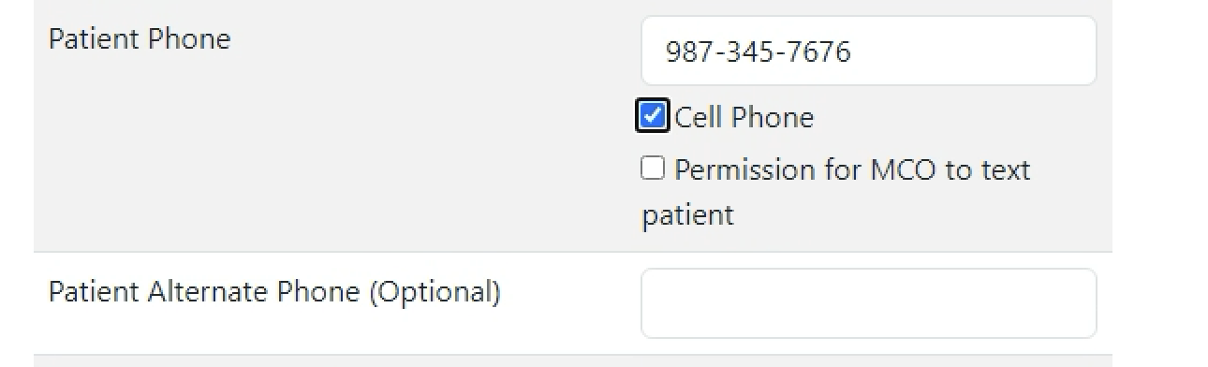

  - If the County does not automatically appear, select from the dropdown.
    - Select Patient County
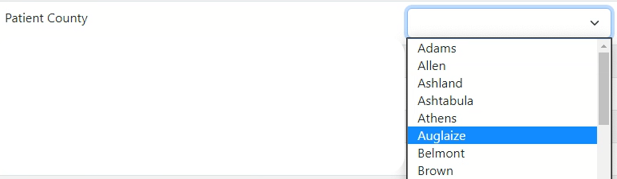
  - Manually select a Provider Contact: "I would like my patient's managed care organization to communicate with my office regarding any urgent needs identified below."
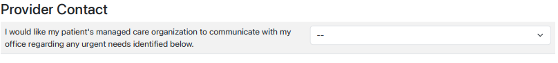
    - Select No/Yes

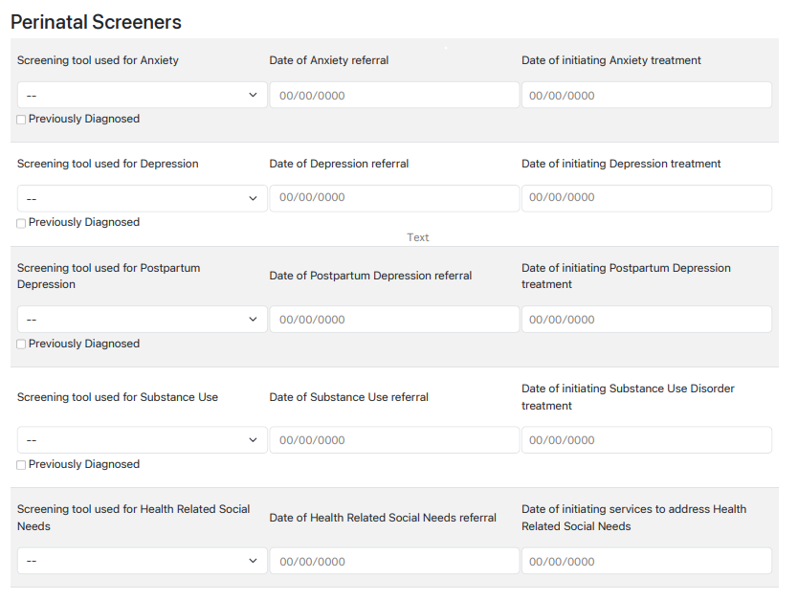
  - Patient Risk Information: Screening info for Anxiety, Depression, Postpartum Depression, Substance Use, and Health Related Social Needs.
Manually select the screening tool used and enter referral and service dates.
  - Review with patient to determine need. Manually select "Patient would benefit from Managed Care and/or County Job and Family Services associated with:"
    - After assessing patient risk, if no assistance is being requested select the following checkbox “Assessment Completed- No Assistance Requested”.
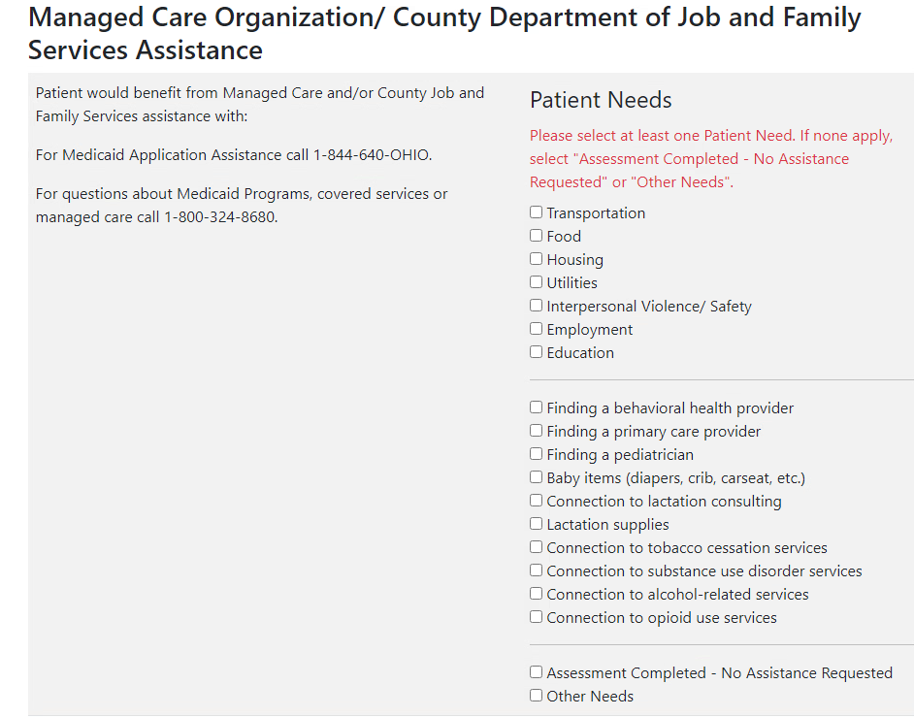
Once the Patient Needs Assessment is completed, the user can select “My patient would benefit from a referral to WIC” or “My patient would benefit from a referral for Help Me Grow Home Visiting.”
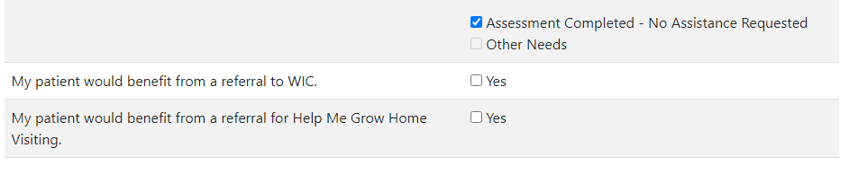Please note that an error message will pop up if nothing has been selected. One Patient Need must be selected. If none apply, select “Assessment Completed- No Assistance Requested” or “Other Needs”.
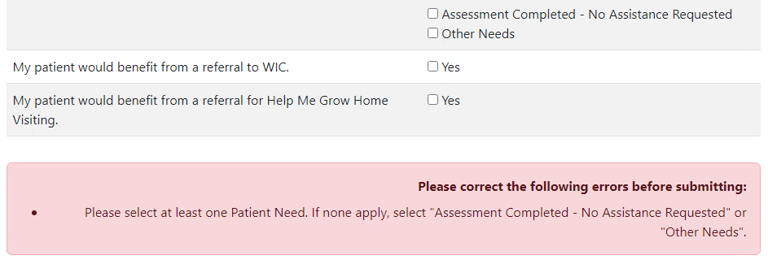
Checking “My patient would benefit from a referral to WIC” or “My patient would benefit from a referral for Help Me Grow Home Visiting” will prompt you for permission to text the patient. You must ensure you have a cell phone listed for either the patient’s primary or alternate phone number listed on the form.
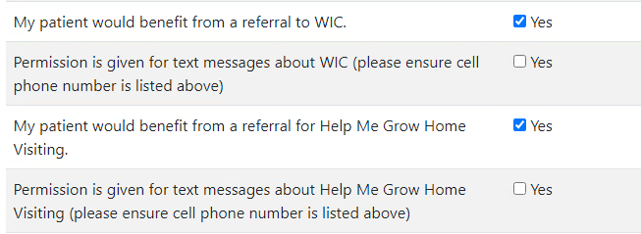
Once all required sections have been completed, click the “Submit” button.
  - Manually provide answers to the risk questions below. Please check all that apply.
    - Prior: If risk was identified in a prior pregnancy
    - Current: If risk is identified in the current pregnancy
    - Postpartum: If the risk is identified in the current postpartum period OR was identified during a previous postpartum period
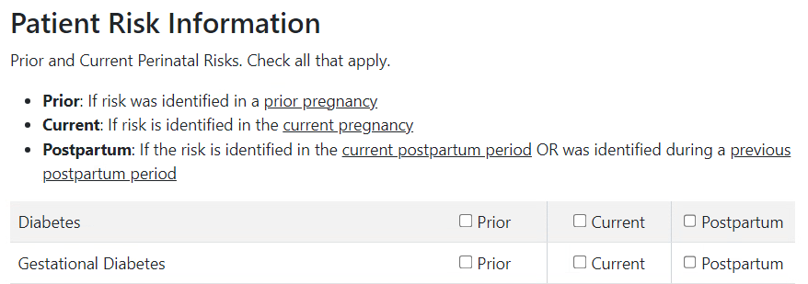

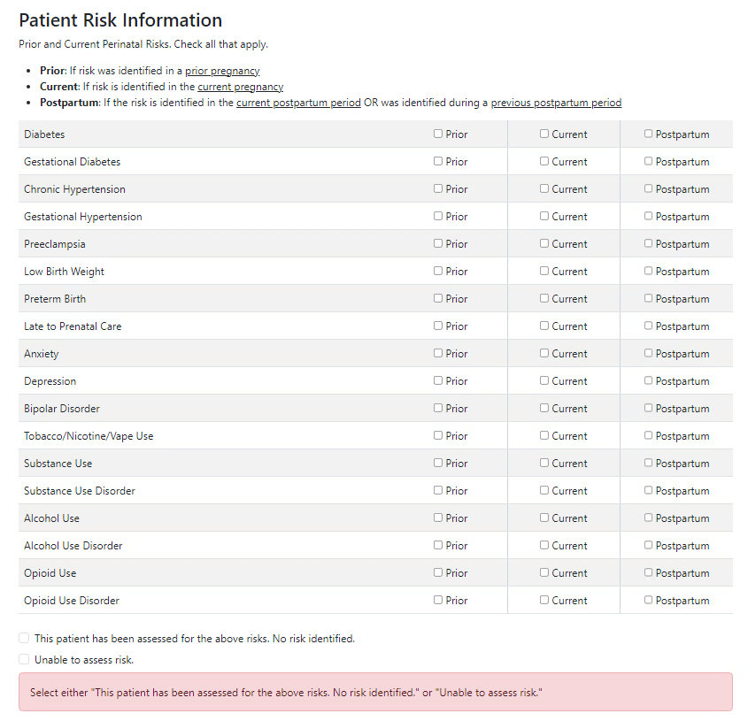
Select a risk or risks from the above list and note if it was from prior, current, or postpartum.
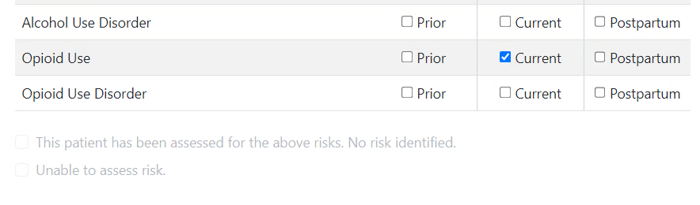
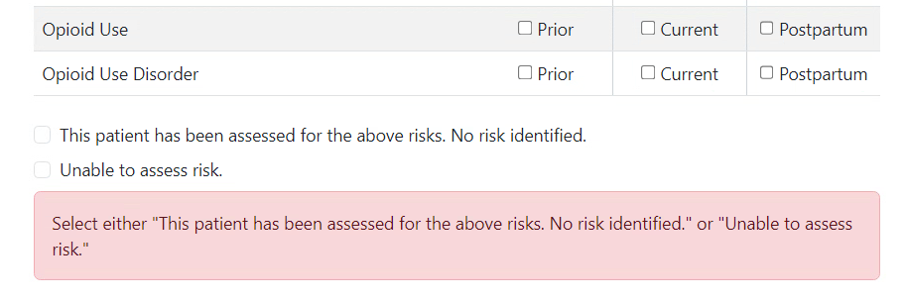
Note that if nothing is selected, an error message will pop up.
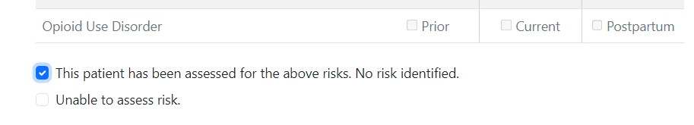
If there are no risks identified, then either select “This patient has been assessed for the above risk. No risk identified.” Or “Unable to assess risk.”

  - When the “Other Needs” checkbox is checked above, PRAF-EHR automatically loads pregnancy-related risk factors from the patient's chart in Epic and displays them in PRAF-EHR's "Other Needs" section (see Appendix A "Other Needs" for the complete risk factor list). If any other risk factors need to be indicated, please specify them in the Additional needs not listed above box in addition to specifying any additional medical or nonmedical needs the patient has.
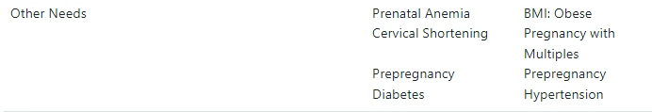

- To send the PRAF-EHR data to NurtureOhio, enter the user token and select the "Send data to NurtureOhio" button which is at the bottom of the PRAF page.

Upon selecting the Send data to NurtureOhio button, the PRAF-EHR data is immediately transmitted to NurtureOhio and a confirmation appears. If a PRAF fails to send due to an error, the end user will see the following message: "There was a problem submitting the PRAF. “
Any of the following error messages may occur:
- “Invalid/Missing Date(s) of Service.”
- “Patient Date of Birth Does Not Match the Patient on File.”
- “Invalid/Missing Patient Medicaid ID.”**
- “Invalid/Missing Patient Name.”
- “Patient Not Found.”
- “Duplicate Patient ID Number.”

If you see any of the above messages, attempt to correct them in the PRAF-EHR and re-send the form using the “Resubmit data to NurtureOhio” option. If you do not resolve the above errors, the PRAF-EHR will not be transmitted to NurtureOhio. If after attempting to resolve, you still have issues, please contact MomsandBabies@medicaid.ohio.gov and/or click the help button in NurtureOhio.

**If the error is “Invalid/Missing Patient Medicaid ID” you can try adding the social security number manually in NurtureOhio as an alternative to the Medicaid Patient ID (MMIS Number).
Note that at this point the PRAF-EHR has not yet been submitted to Ohio Department of Medicaid. It has only been transferred to NurtureOhio where the form's status will be an "In Process-EHR."
The transmitted PRAF data can then be viewed immediately by logging in to the NurtureOhio website.

To view, select the NurtureOhio PRAF 2.0 Patient Forms tab. All of the PRAF-EHR forms that were transmitted will appear in the list. Because the EHR token was used, the Practice, Provider and User information recorded in the PNM will be automatically added to each PRAF-EHR record. The PRAF will display in blue within NurtureOhio to indicate it was submitted through the PRAF-EHR.
From within the NurtureOhio website, the PRAF-EHR transmitted forms can be edited and submitted for validation just like a manually entered form. If a mistake was made in data entry in the PRAF-EHR, the mistake can be corrected; if a form is submitted for validation and rejected, the form can be edited and resubmitted.
When the PRAF-EHR’s validation fails for the MMIS/Patient Medicaid ID, the MMIS/Patient Medicaid ID is removed and the user can enter the correct MMIS/Patient Medicaid ID manually within NurtureOhio. If the MMIS/Patient Medicaid ID is not known, the user can check “Patient Medicaid ID Not Known” and enter the patient’s SSN in the appropriate box.
If you unintentionally hit submit more than once, it will send a duplicate record. Please email Momsandbabies@medicaid.ohio.gov to have duplicates removed.

Appendix A - list of PRAF data values that may be pulled from EHR

Date of Service
Patient MMIS Number*
Patient First Name*
Patient Last Name*
Estimated date of confinement
Gestational Weeks
Name of Medicaid Managed Care Organization
Number of Fetuses
Patient Date of Birth*
Patient Street
Patient City
Patient State
Patient Zip Code
Patient Phone
Primary Language is English
Primary Language (if not English)
How does the patient describe their ethnicity?
How does the patient describe their race?

*Indicates required field

Other Needs
Pre-pregnancy hypertension
Pre-pregnancy diabetes
BMI (obesity; underweight)
Severe mental illness
Previous preterm birth
Poor pregnancy outcome
Prenatal anemia
High risk pregnancy
Cervical shortening
Congenital anomaly
Pregnancy with multiples
Preeclampsia
Gestational hypertension
Poor fetal growth

Appendix B - List of PRAF manual entry fields:
If any of the fields in Appendix A cannot be pulled in from the Patient’s Epic Electronic Health Record (EHR), those values can typed in or selected manually.
- NurtureOhio Token*
- Gestational Days
- Date of Delivery
- Patient Alternate Phone (Optional)
- Provider Contact: I would like my patient's managed care plan, home health, and/or pharmacy to communicate with my office regarding any urgent needs identified below.
- Patient Risk Information Screening tool related questions.
  - Screening tools used for Anxiety, Depression, Postpartum Depression, Substance Use, and Health Related Social Needs. Each of these five conditions has 4 manual entry fields:
    - Select screening tool from dropdown
    - Enter date of referral
    - Enter date of service
    - Previously Diagnosed checkbox
- Patient would benefit from Managed Care and/or County Job and Family Services assistance with: For Medicaid Application Assistance call 1-844-640-OHIO. For questions about Medicaid Programs, covered services or managed care call 1-800-324-8680. Some checkboxes may appear pre-checked based on Patient’s EHR. All checkboxes can be manually checked and unchecked.
  - List of checkboxes can be manually selected
- Additional needs not listed above:
  - Any needs not listed in the “Patient would benefit…” checkboxes can be manually entered in this field
- Current and Prior Perinatal Risks
- My patient would benefit from a referral to WIC.
- My patient would benefit from a referral for Home Visiting.

*Indicates required field

